PAARA Dec. 3rd Meeting and “Event of the Year”
“Dream to Reality Raffle VII” with over $1600 in prizes
SPEAKER: ERIC SWARTZ, WA6HHQ
PROGRAMS: (ELECRAFT K3 Features & Developments) / also “Homebrew Night”
Do not miss this special evening with Elecraft’s Eric Swartz talking about the PAARA Raffle 1st prize Elecraft K3.
This is your night for “show and tell”! Bring in your favorite original design, kit, boat anchor refurbish, or anything that is ham radio related and show it off. We will have a panel of judges for grading the designs and PAARA will provide awards for the top 3 entries.
But wait, there is more! We also have the “Dream to Reality Raffle” with the “top of the line” Elecraft K3. Raffle tickets will be sold until 9:30. YOU MUST BE PRESENT TO WIN THE GRAND PRIZE, WE KEEP PULLING TICKETS UNTIL WE GET A LIVE ONE.
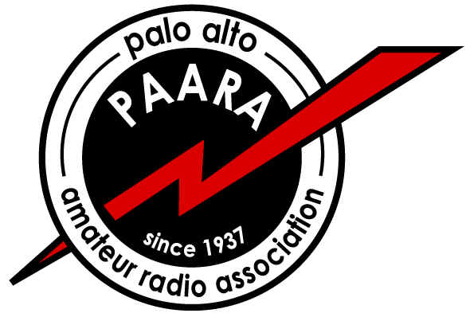
PAARA “The Friendliest Club Around”
Palo Alto Amateur Radio Association, Inc. www.paara.org
Date and Time: Friday, Dec. 3rd, at 7 p.m.
Menlo Park Rec. Center / Council Chambers
700 Alma St., Menlo Park, CA.
Welcome Members and Visitors / Raffle Prizes:

FIRST PRIZE: Elecraft K3 HF- 6m
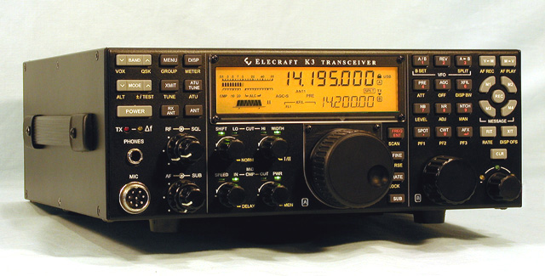
Ultra-High Performance Transceiver 200thraffle radio since Feb.2003

“Special Thanks to Elecraft”
• Main Receiver and Sub-Receiver Feature a High-Dynamic-
Range, Down-Conversion Analog Architecture
• Roofing Filters with Bandwidths as Narrow as 200 Hz
• Both Fixed- And Variable-Bandwidth Crystal Filters in
Both Data, CW, and Voice-Mode Bandwidths
• Two 32-bit Digital Signal Processors Provide True
Software-Defined Features, Along With Expansion
Memory to Handle Future Signal Processing Tasks

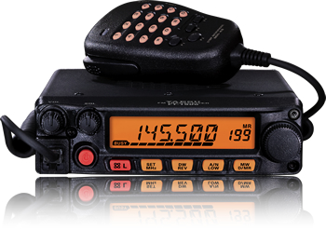
SECOND PRIZE: YAESU FT-1900R
“New” 2m / 55W / Mobile
• Extended Receiver Coverage 136-174 MHz
• Illuminated Microphone with Keyboard Frequency Entry and Recall
• 200 Memory Channels with Alpha-numeric Labeling
• Dedicated 10-Channel NOAA Weather Broadcast Channels
• Adjustable Mic Gain and Wide/Narrow Deviation and RX Bandwidth

THIRD PRIZE: Solarlink FR-500 AM/FM/SW Radio / Flashlight / Cell Phone Charger

FOURTH PRIZE: Two FRS Radios

FIFTH PRIZE: CR-2 Short Wave Radio Kit
SIXTH PRIZE: DBJ-1 / VHF-UHF Dual-Band J-Pole
SEVENTH PRIZE: Programmable Message Fan
EIGHT PRIZE: Gordon West / 6 Tape Set / 10-28 wpm / CW Speed Builder
NINTH PRIZE: Nine-LED Flashlight
Since Feb. 03, 194 Radios, including Three Elecraft K3’s, a Yaesu FT-847, an Icom 706
MK IIG, a Yaesu FT-897D, and TWO Elecraft KX1’s have gone to Fellow Hams.
Special Thanks to Howard, Jon, Mark, and everyone at HRO for their continued SUPPORT!
K6AK Jim

